***BOOK THE BEST HOTEL IN SOFIA FOR WOM23***

**GRAND MILLENNIUM HOTEL SOFIA \*\*\*\*\***

**VENUE HOTEL**

Grand Hotel Millennium Sofia embodies an elegant combination of gilded brilliance, innovation, and service at the highest heights.. An excellent property in the heart of Sofia, it will satisfy all your needs at reasonable prices.

Book Now with Official Housing Bureau!

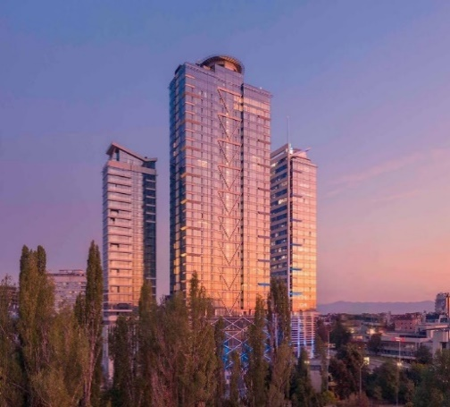

**For more information and accommodation offers, please contact:**

Mrs. Antonia Nikolova  
Hotel Sales Specialist  
Tel: T: 0041 22 908 0488 Ext.226      
Email: [anikolova@kenes.com](mailto:anikolova@kenes.com)